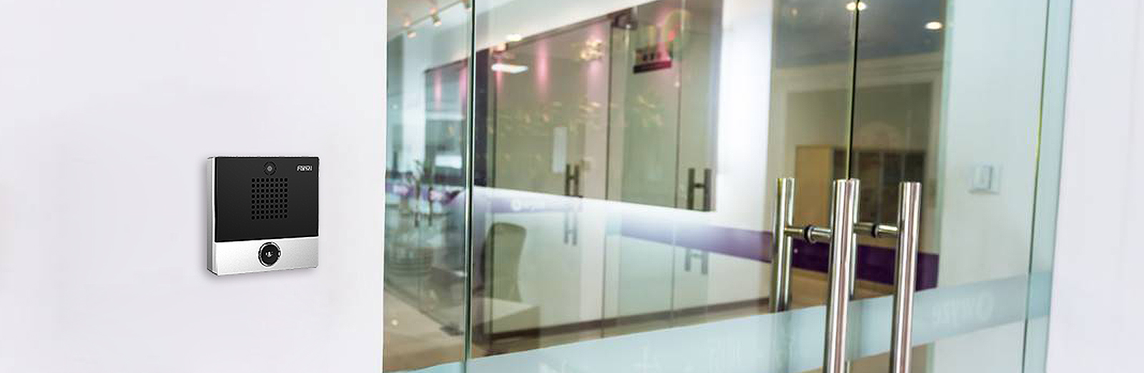


Fanvil i10S/i10SV/i10SD SIP Mini Intercom
The i10S/i10SV/i10SD SIP mini intercom is designed for indoor scenes with IP54 waterproof and dustproof. Supports wall mounting installation. It combines security, audio/video intercom and broadcasting functionalities and offers the qualified communication solution for users.  Highlights  Easy installation and configuration.  IP54 waterproof and dustproof.  -20 °C to 50 °C wide range temperature adaptability.  Built-in 1W speaker and Acoustic Echo Canceller (AEC).  Built-in 1short circuit input/output interface.  Functionality including security, intercom and broadcasting.  Built-in HD camera and with backlight compensation function (for i10SV).  Adaptive 10/100 Mbps network port, integrated PoE  Compatible with major platforms: Asterisk, Broadsoft, 3CX, Metaswitch, Elastix, Avaya etc. | i10S i10SV i10SD            
  Model | Screen | Button | Camera
  i10S | 10/100Mbps | 1 | ×
  i10SV | 10/100Mbps | 1 | √
  i10SD | 10/100Mbps | 2 | ×
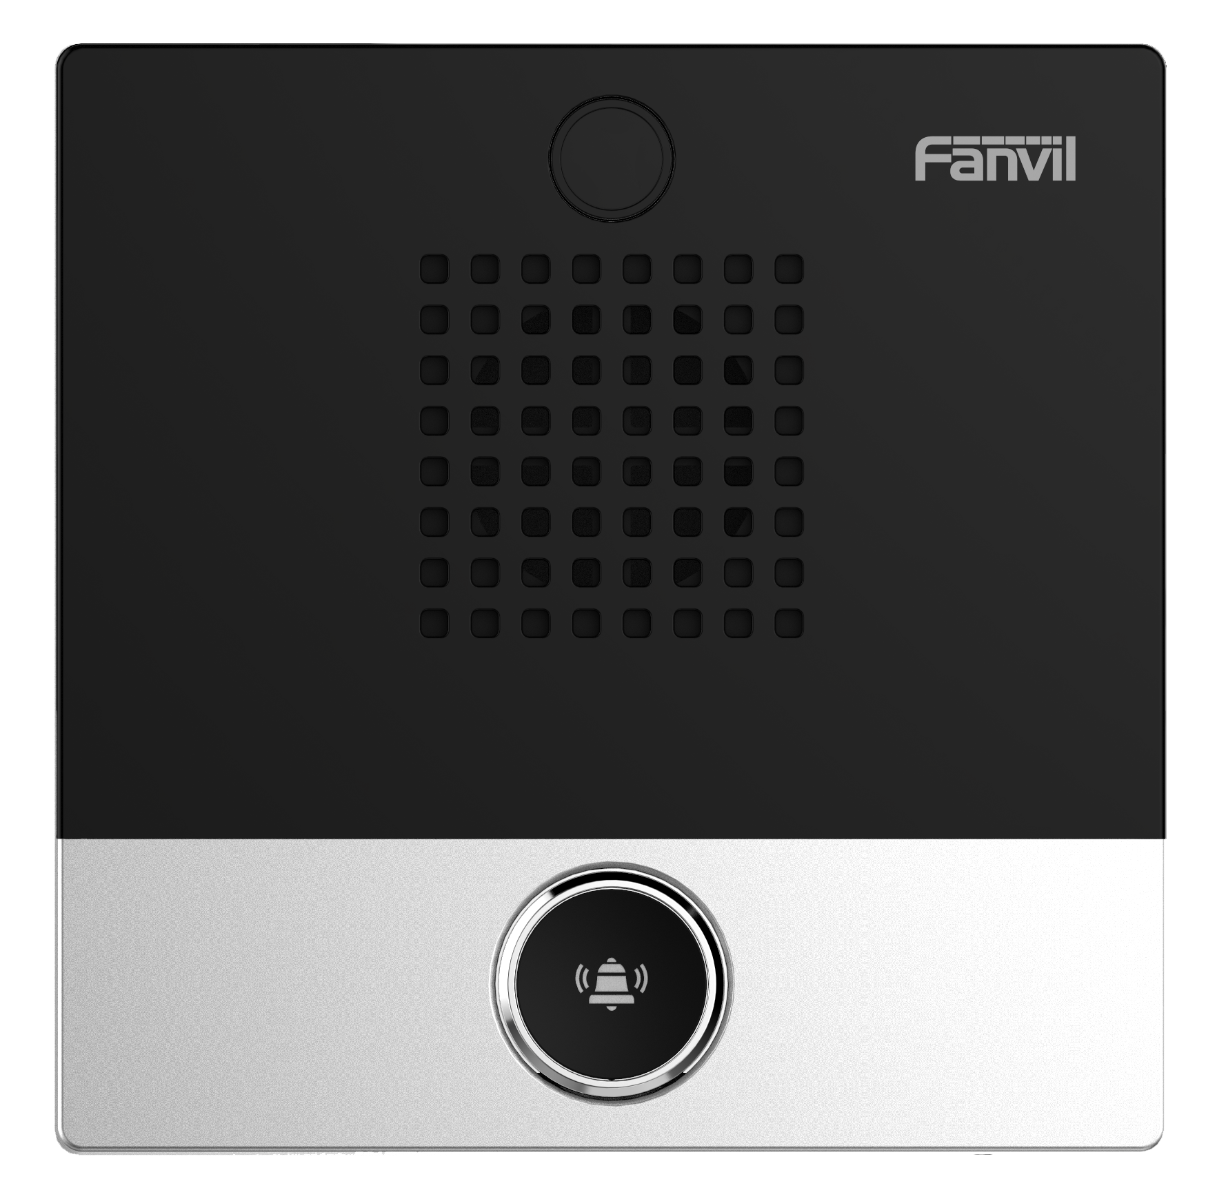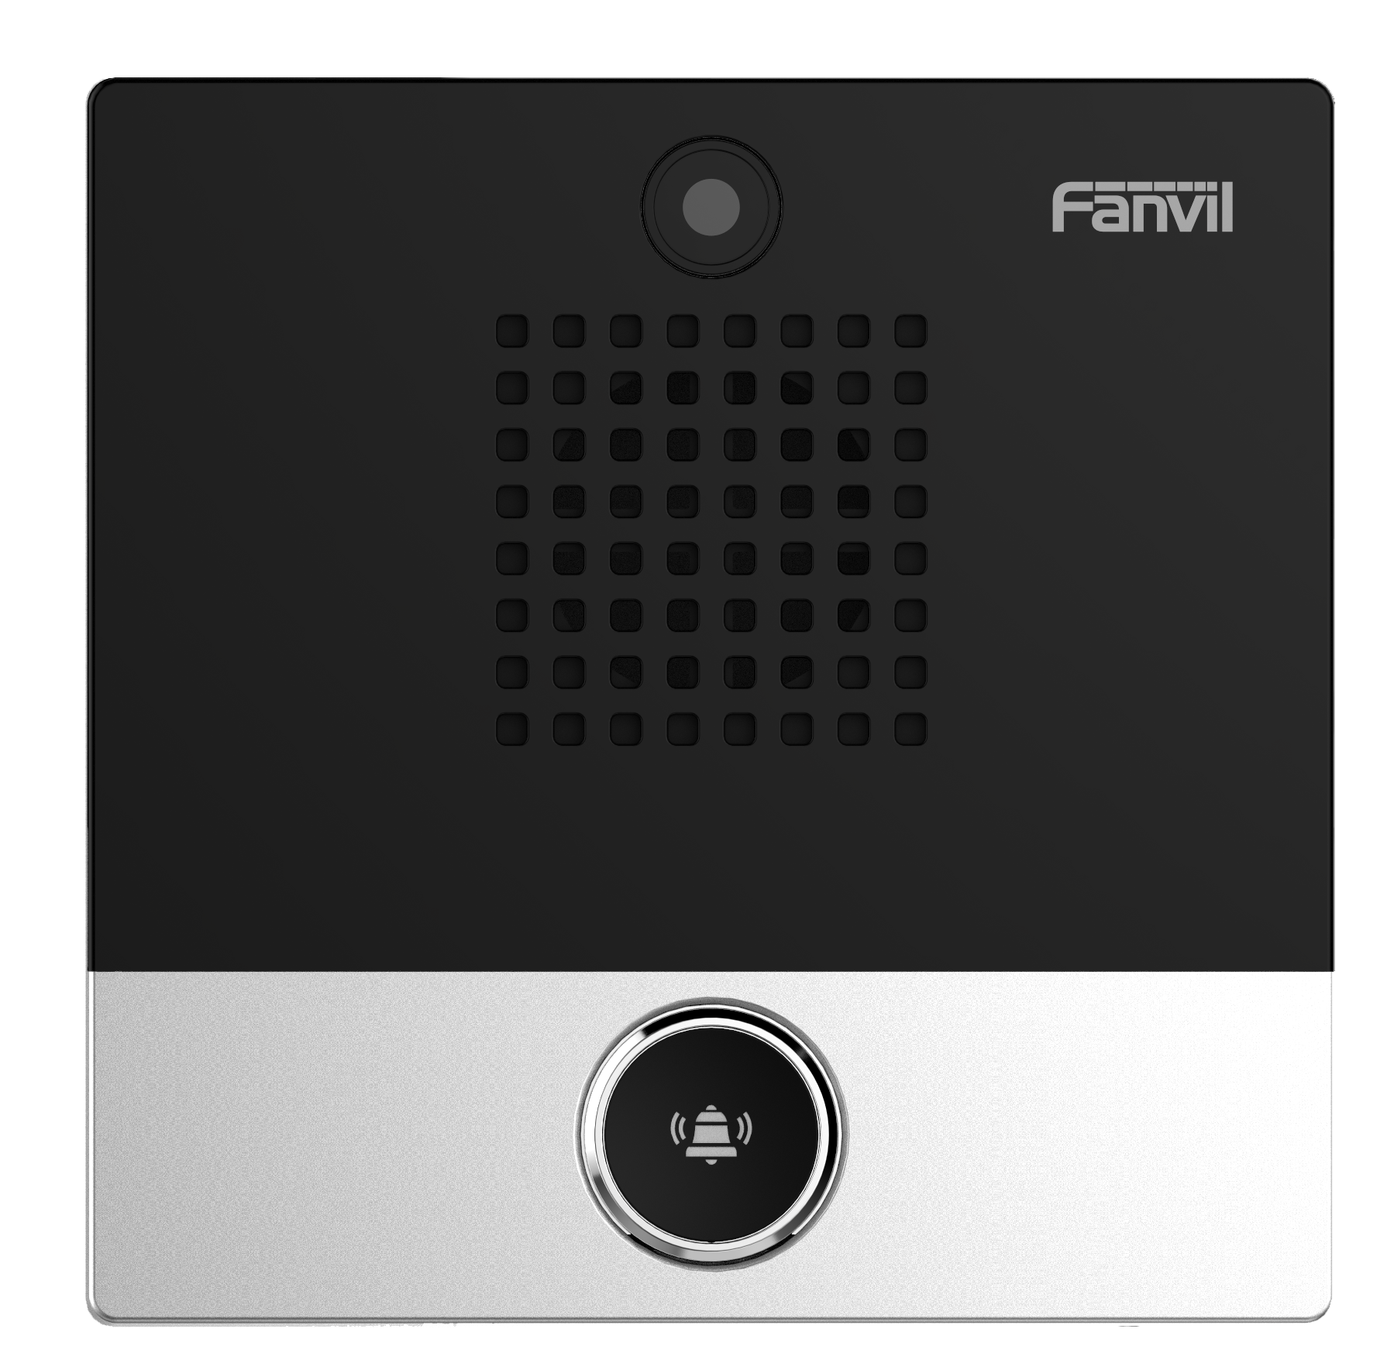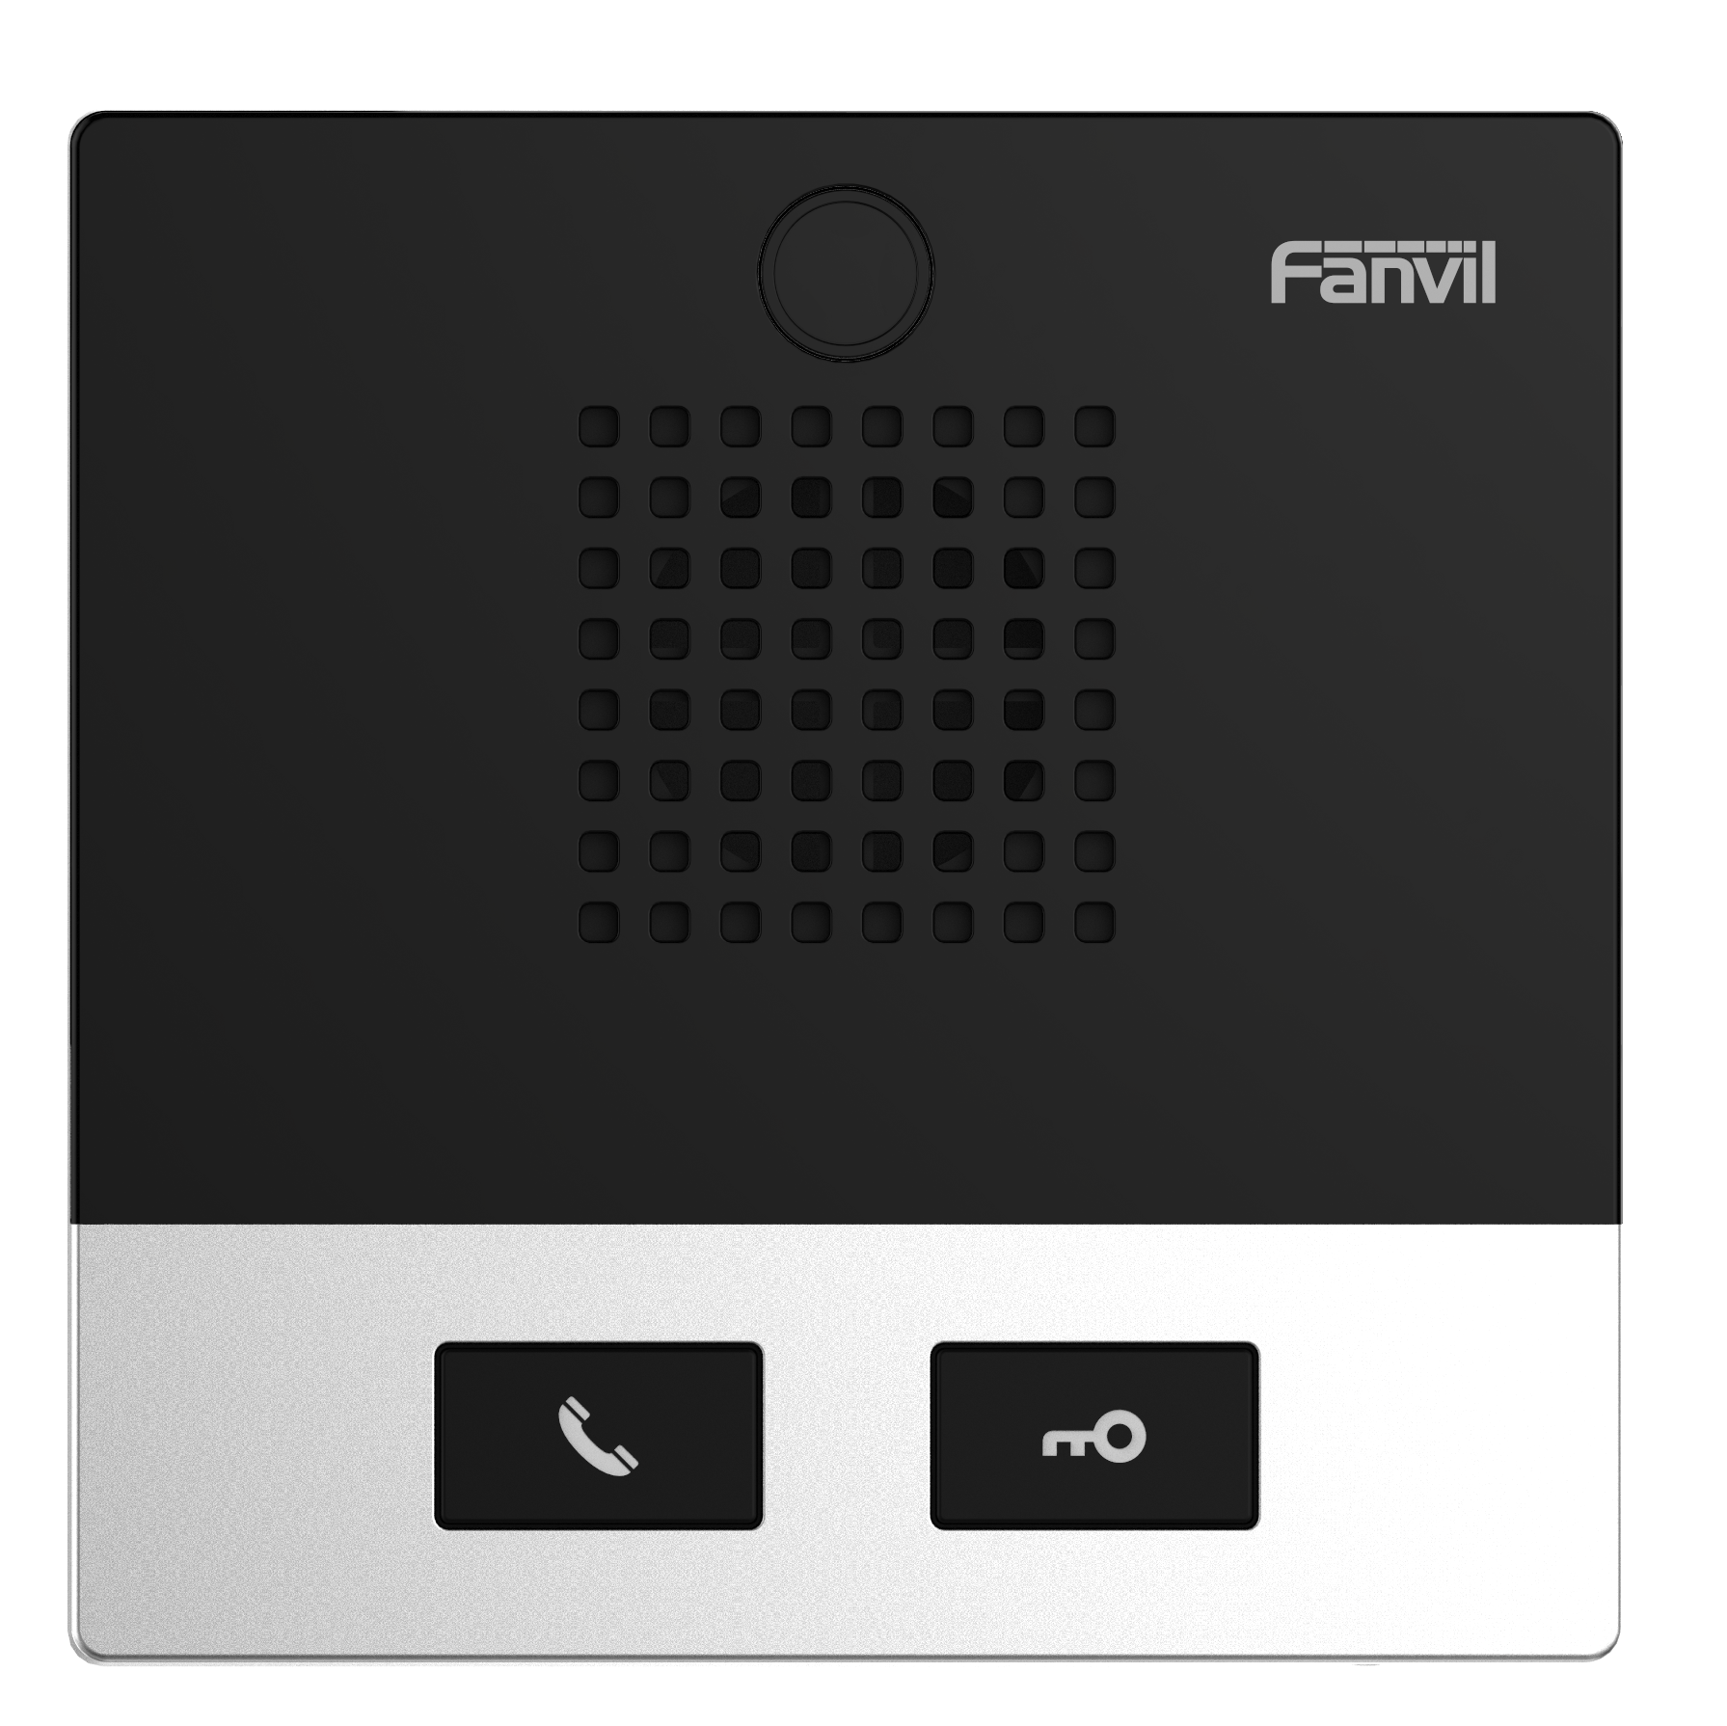

Generic
- 2 SIP lines
- Speed dial
- Linkage with IP camera to realize video intercom
- Oral announcement of the IP address(in English)
- Switch signal input and output
- Support programmable DSS key ports
- PoE enabled

Device Functions
- Auto-answering
- Programmable DSS keys
- Through web page volume adjustment
- Network time synchronization
- Time plan (task management)
- Dynamic multicast function
- Incoming call multicast
- HTTP API
- Action URL / Active URI

Call Functions
- Call out / answer / reject
- Call waiting
- Intercom, Multicast
- Speed dial
- Anonymous call (Hide caller ID)

Audio
- Narrowband codec: G.711A/U, G.729A/B
- Wideband codec: G.722, Opus
- Full-duplex hands-free speakerphone with AEC
- DTMF: In-band, Out-of-Band (RFC2833/ SIP INFO)

Video (Only i10SV)
- Sensor: 1/5” color CMOS
- Pixels: 2 Mega
- Video coding: H.264
- Resolution: 720P, 1080P
- Minimum illumination: 40%
- Viewing angle:
- Diagonal: 73°
- Horizontal: 63.3°
- Vertical: 49.6°

Network
- Physical: 10/100 Mbps Ethernet
- IP mode:IPv4/IPv6/IPv4&IPv6
- IP configuration: Static IP / DHCP / PPPoE
- VPN: L2TP / OpenVPN

Protocols
- SIP v1 (RFC2543), v2 (RFC3261) over UDP/TCP/TLS
- RTP/RTCP/SRTP
- STUN
- DHCP
- IPv6
- PPPoE
- L2TP

- OpenVPN
- SNTP
- FTP/TFTP
- HTTP/HTTPS
- TR-069

Deployment & Management
- Auto-provisioning via FTP/TFTP/HTTP/HTTPS/DHCP OPT66/SIP PNP/TR-069
- Web management portal
- Web-based packet dump
- Configuration export / import
- Firmware upgrade
- Syslog

Physical Specifications
- DSS Keys, follow model
- i10S/i10SV: 1 DSS key (speed dial key)
- i10SD: 2 DSS keys
- RJ45 port x1: connect the network
- WAN port: connect the network, support PoE

- Short circuit input and output port x1 (built-in relay)
- Relay: MAX DC30V / 1A, AC125V / 0.5A
- Port: terminal socket
- DC port: DC power input
- DC power input: DC12V / 1A
- Port: terminal socket
- PoE level: Class 3
- Protection level: IP54
- Housing material: ABS
- Installation: Wall-mounted
- Working temperature: -20℃ ~ 50℃
- Storage temperature: - 30℃ ~ 60℃
- Working humidity: 10~95%
- Device dimensions: 88x88x32 mm
- Gift box dimensions: 95x108x40 mm
- Outer CTN dimensions: 241x225x215 mm (20 PCS)

The above specifications may be updated in the future without prior notice. All hardware/software/physical features should be based on the final shipped products.
For more information, please visit: www.fanvil.com

Compatibility List:


www.fanvil.com
Add: 10/F Block A, Dualshine Global Science Innovation Center, Honglang North 2nd Road, Bao'an District, Shenzhen, China
Tel: +86-755-2640-2199 Fax: +86-755-2640-2618 Email: sales@fanvil.com

