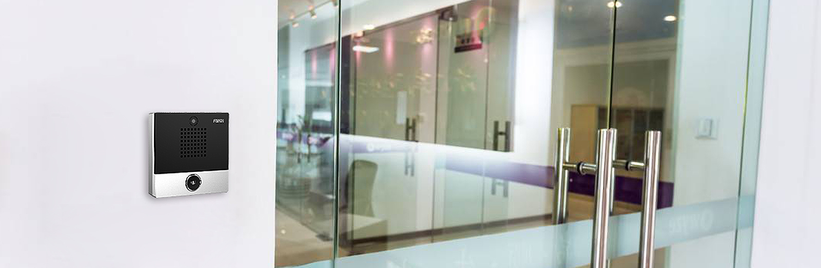





**Fanvil i10S/i10SV/i10SD SIP Mini Intercom**

|  |  |  |  |  |  |  |  |  |  |  |  |  |  |  |  |  |  |
| --- | --- | --- | --- | --- | --- | --- | --- | --- | --- | --- | --- | --- | --- | --- | --- | --- | --- |
| The i10S/i10SV/i10SD SIP mini intercom is designed for indoor scenes with IP54 waterproof and dustproof. Supports wall mounting installation. It combines security, audio/video intercom and broadcasting functionalities and offers the qualified communication solution for users.  **Highlights**  Easy installation and configuration.  IP54 waterproof and dustproof.  -20 °C to 50 °C wide range temperature adaptability.  Built-in 1W speaker and Acoustic Echo Canceller (AEC).  Built-in 1short circuit input/output interface.  Functionality including security, intercom and broadcasting.  Built-in HD camera and with backlight compensation function (for i10SV).  Adaptive 10/100 Mbps network port, integrated PoE  Compatible with major platforms: Asterisk, Broadsoft, 3CX, Metaswitch, Elastix, Avaya etc. | i10S i10SV i10SD   |  |  |  |  | | --- | --- | --- | --- | | **Model** | **Screen** | **Button** | **Camera** | | **i10S** | 10/100Mbps | 1 | × | | **i10SV** | 10/100Mbps | 1 | √ | | **i10SD** | 10/100Mbps | 2 | × | |

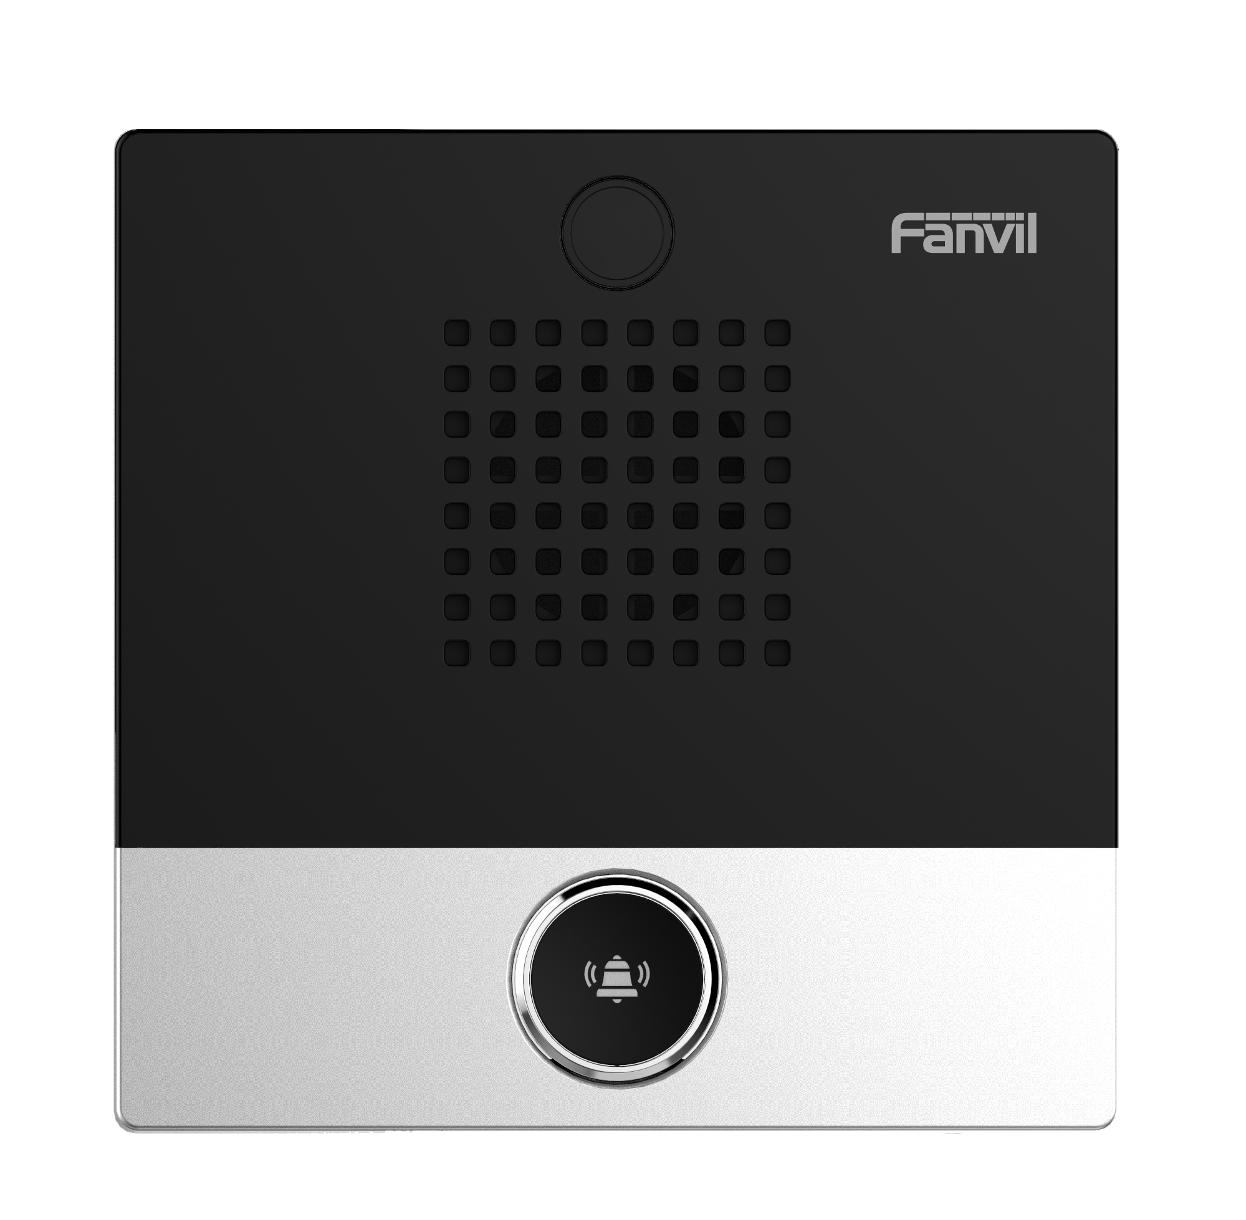 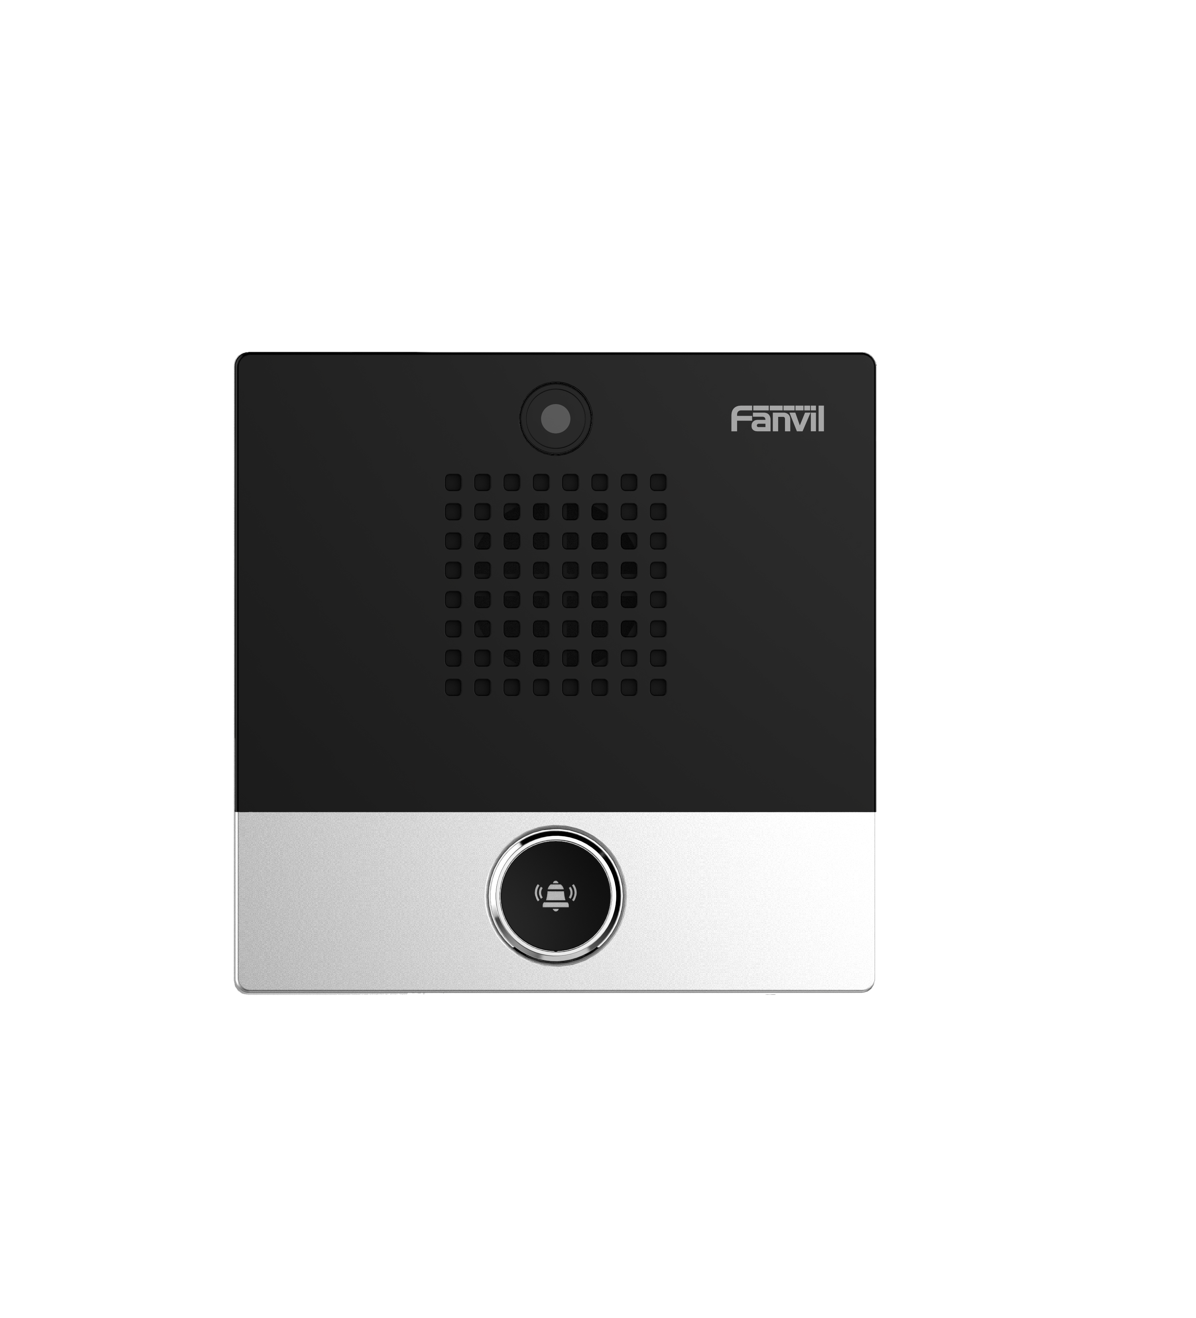 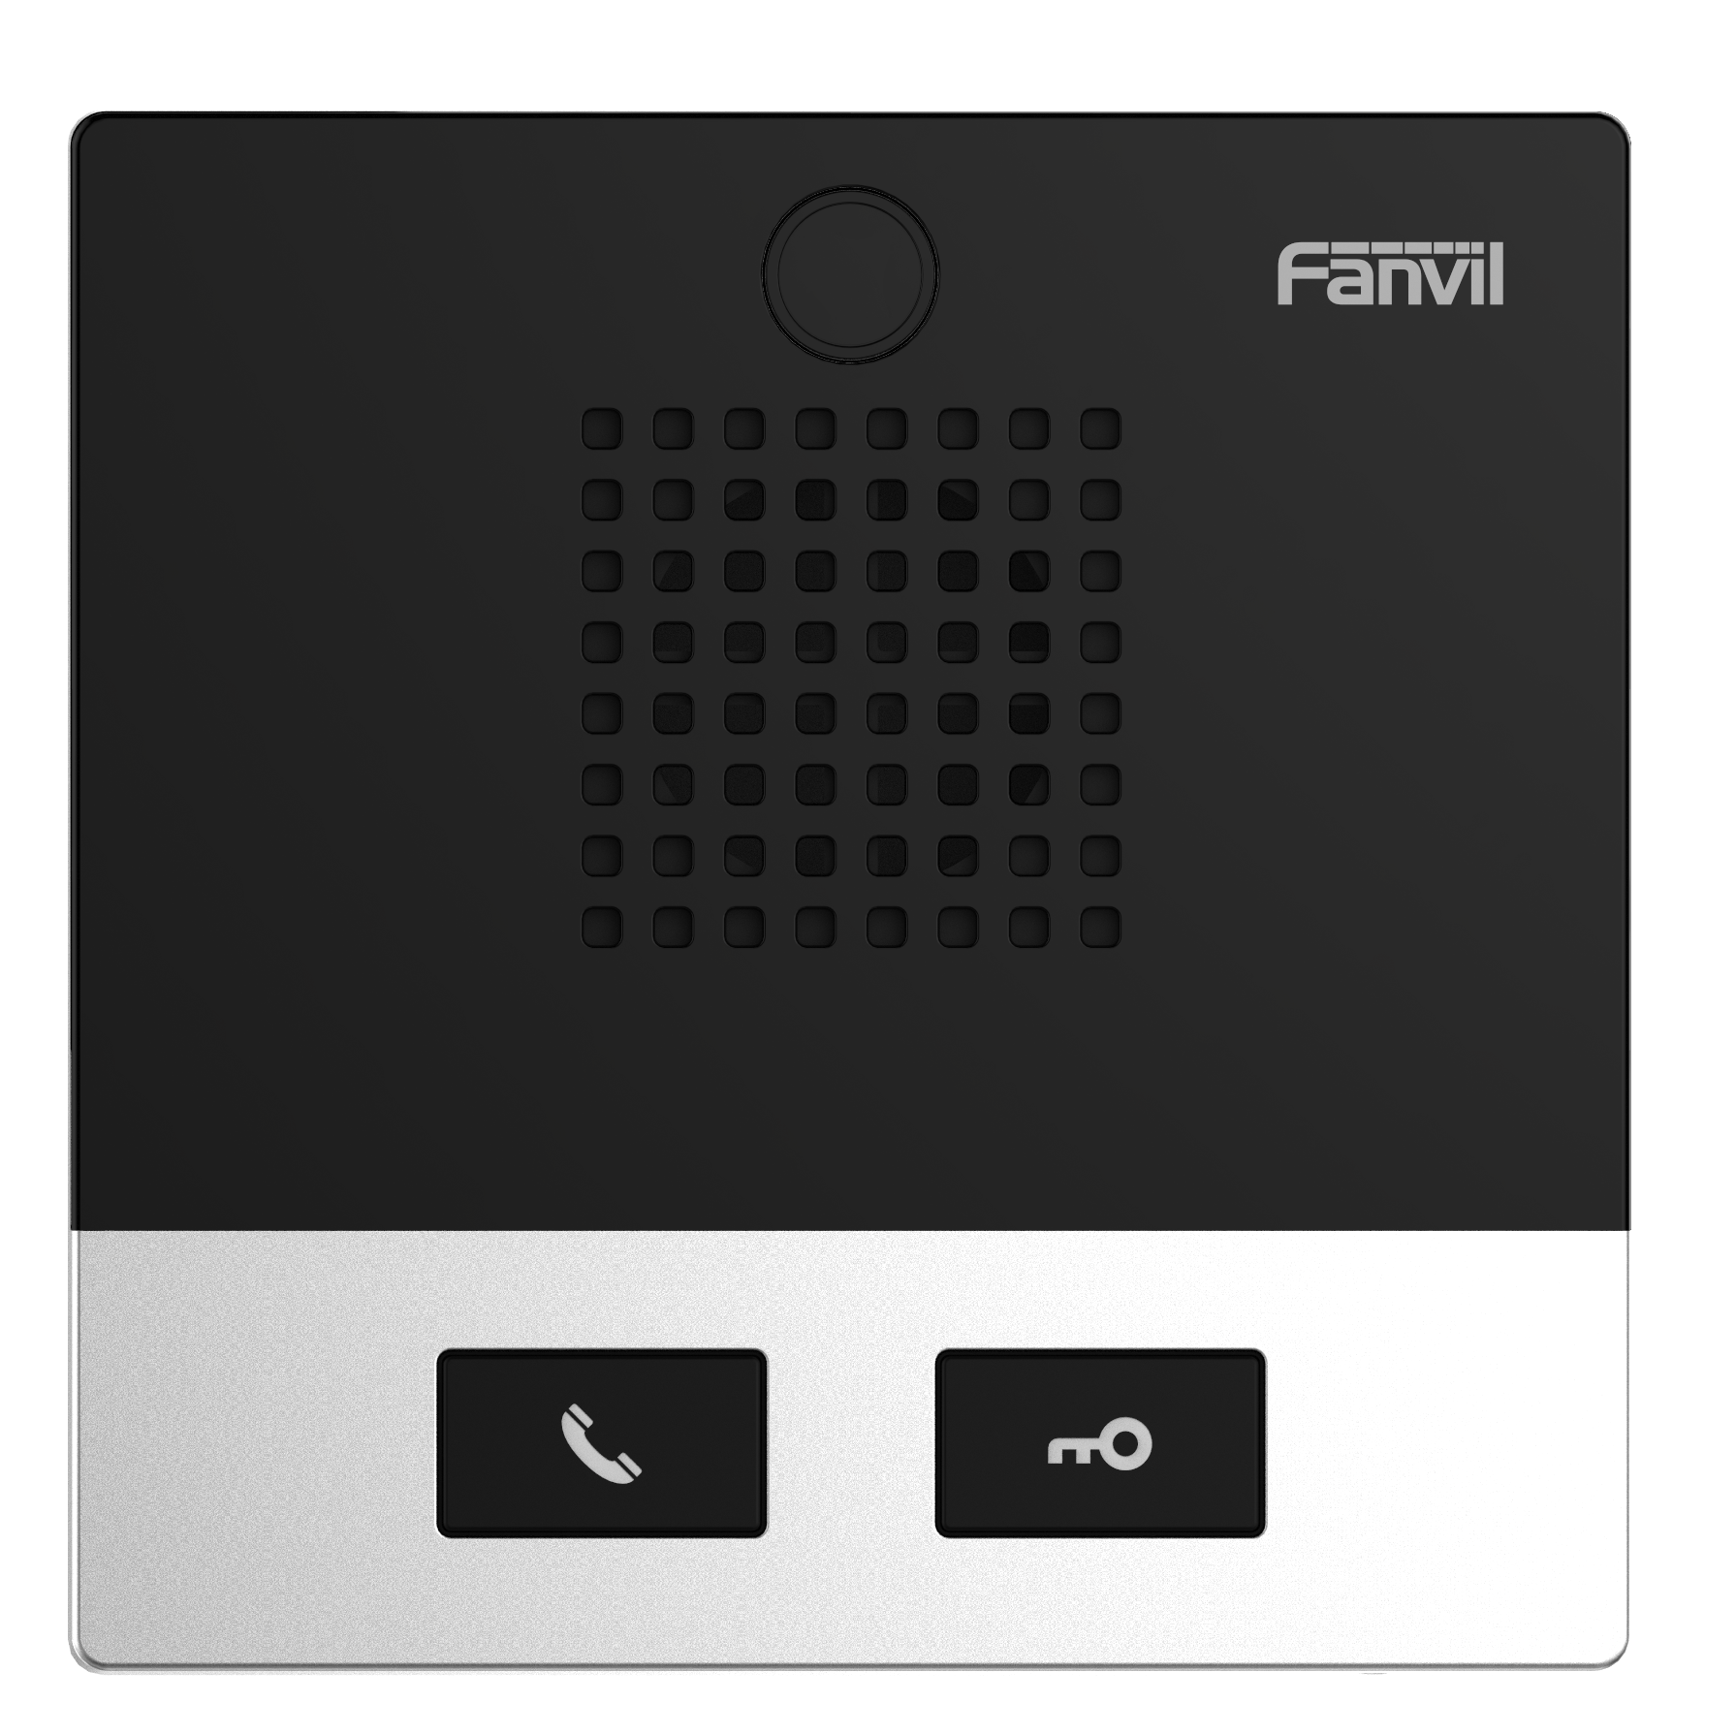

**Generic**

* 2 SIP lines
* Speed dial
* Linkage with IP camera to realize video intercom
* Oral announcement of the IP address(in English)
* Switch signal input and output
* Support programmable DSS key ports
* PoE enabled

**Device Functions**

* Auto-answering
* Programmable DSS keys
* Through web page volume adjustment
* Network time synchronization
* Time plan (task management)
* Dynamic multicast function
* Incoming call multicast
* HTTP API
* Action URL / Active URI

**Call Functions**

* Call out / answer / reject
* Call waiting
* Intercom, Multicast
* Speed dial
* Anonymous call (Hide caller ID)

**Audio**

* Narrowband codec: G.711A/U, G.729A/B
* Wideband codec: G.722, Opus
* Full-duplex hands-free speakerphone with AEC
* DTMF: In-band, Out-of-Band (RFC2833/ SIP INFO)

**Video (Only i10SV)**

* Sensor: 1/5” color CMOS
* Pixels: 2 Mega
* Video coding: H.264
* Resolution: 720P, 1080P
* Minimum illumination: 40%
* Viewing angle:
* Diagonal: 73°
* Horizontal: 63.3°
* Vertical: 49.6°

**Network**

* Physical: 10/100 Mbps Ethernet
* IP mode:IPv4/IPv6/IPv4&IPv6
* IP configuration: Static IP / DHCP / PPPoE
* VPN: L2TP / OpenVPN

**Protocols**

* SIP v1 (RFC2543), v2 (RFC3261) over UDP/TCP/TLS
* RTP/RTCP/SRTP
* STUN
* DHCP
* IPv6
* PPPoE
* L2TP
* OpenVPN
* SNTP
* FTP/TFTP
* HTTP/HTTPS
* TR-069

**Deployment & Management**

* Auto-provisioning via FTP/TFTP/HTTP/HTTPS/DHCP OPT66/SIP PNP/TR-069
* Web management portal
* Web-based packet dump
* Configuration export / import
* Firmware upgrade
* Syslog

**Physical Specifications**

* DSS Keys, follow model
* i10S/i10SV: 1 DSS key (speed dial key)
* i10SD: 2 DSS keys
* RJ45 port x1: connect the network
* WAN port: connect the network, support PoE
* Short circuit input and output port x1 (built-in relay)
* Relay: MAX DC30V / 1A, AC125V / 0.5A
* Port: terminal socket
* DC port: DC power input
* DC power input: DC12V / 1A
* Port: terminal socket
* PoE level: Class 3
* Protection level: IP54
* Housing material: ABS
* Installation: Wall-mounted
* Working temperature: -20℃ ~ 50℃
* Storage temperature: - 30℃ ~ 60℃
* Working humidity: 10~95%
* Device dimensions: 88x88x32 mm
* Gift box dimensions: 95x108x40 mm
* Outer CTN dimensions: 241x225x215 mm (20 PCS)

The above specifications may be updated in the future without prior notice. All hardware/software/physical features should be based on the final shipped products.

For more information, please visit: [www.fanvil.com](http://www.fanvil.com)

**Compatibility List:**





www.fanvil.com

Add: 10/F Block A, Dualshine Global Science Innovation Center, Honglang North 2nd Road, Bao'an District, Shenzhen, China

Tel: +86-755-2640-2199 Fax: +86-755-2640-2618 Email: [sales@fanvil.com](mailto:sales@fanvil.com)

