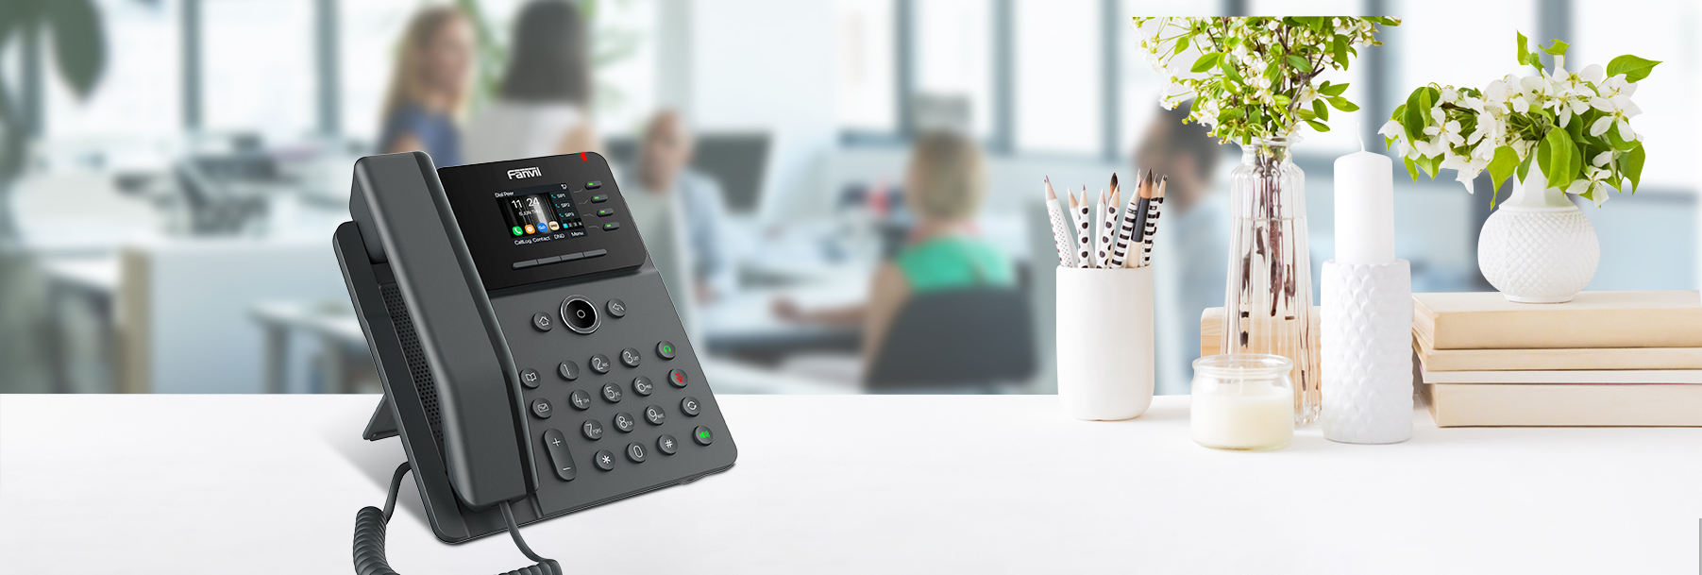



**V61G** **Entry Level IP Phone**

|  |  |
| --- | --- |
| The V61G is a stylish and user-friendly entry-level Gigabit color screen SIP phone that offers exceptional performance. It supports 4 SIP lines and a 6-way audio conference, featuring a 2.4-inch 320x240 pixel color screen. With dual network ports and integrated PoE, the V61G also boasts HD audio and the Opus audio codec among other rich functionalities, ensuring users enjoy high-quality communications.  **Highlights**  2.4” color screen  Support audio codec G.722 and Opus, HD audio on speakerphone and handset  Support 6-way Audio conference  Available to link with security products, can be easily customized into various security solutions for reducing investment  Dual Gigabit ports, integrated PoE  Up to 12 DSS keys, every DSS key can be set as Line/BLF/ Speed Dial Key |  |

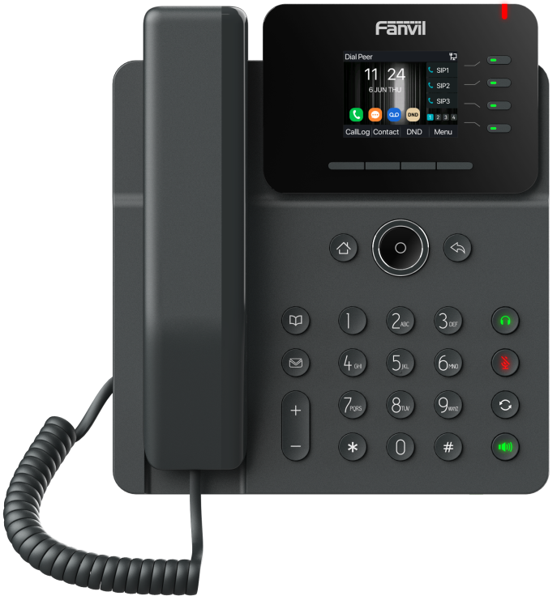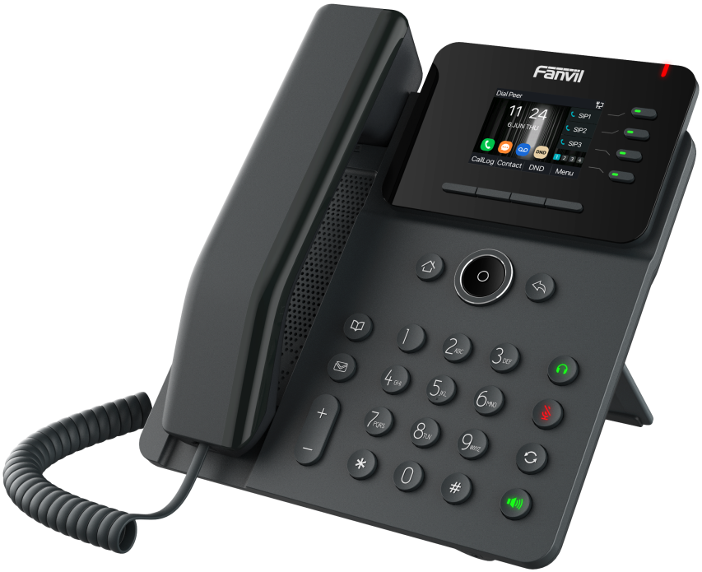

**Generic**

* 2.4-inch (320x240) color screen
* 4 SIP lines
* HD voice
* Dual Gigabit ports, PoE enabled
* Intelligent DSS keys
* Handset / hands-free / headset mode
* Desktop Stand / Wall-mounted (optional)
* Optional external power supply
* Handset with hall switch

**Phone Features**

* Local Phonebook (1000 entries)
* Remote Phonebook (XML/LDAP)
* Call logs (In/out/missed, 1000 entries)
* Blocked List/Allowed List
* Screen saver
* Voice Message Waiting Indication (VMWI)
* Programmable DSS/Soft keys
* Network Time Synchronization
* Support Poly wireless headset (Through Poly APD-80 EHS Cable)
* Support Jabra wireless headset (Through Fanvil EHS20 EHS Cable)
* Support Recording(through server)
* Action URL / Active URI
* uaCSTA
* Dial Plan
* SIP Hotspot
* Multicast
* Action Plan
* Group listening

**Call Features**

* Call out / Answer / Reject
* Mute / Unmute (Microphone)
* Call Hold / Resume
* Call Waiting
* Intercom
* Caller ID Display
* Speed Dial
* Anonymous Call (Hide Caller ID)
* Call Forwarding (Always/Busy/No Answer)
* Call Transfer (Attended/Unattended)
* BLF
* Call Parking/Pick-up (Depending on server)
* Redial
* Do-Not-Disturb
* Auto-Answering
* Voice Message (With server)
* 6-way Audio Conference
* Hot Line
* Hot Desking

**Audio**

* HD Voice Microphone/Speaker (Handset/Hands-free, 0 ~ 7KHz Frequency Response)
* HAC handset
* Wideband ADC/DAC 16KHz Sampling
* Narrowband Codec: G.711a/u, G.723.1, G.726, G.729, G.729A, G.729B, G.729AB, iLBC
* Wideband Codec: G.722, Opus
* Full-duplex Acoustic Echo Canceller (AEC)
* Voice Activity Detection (VAD) / Comfort Noise Generation (CNG) / Background Noise Estimation (BNE) / Noise Reduction (NR) / Automatic Gain Control (AGC)
* Packet Loss Concealment (PLC)
* Dynamic Adaptive Jitter Buffer
* DTMF: In-band, Out-of-Band (RFC2833/ SIP INFO)
* VQM voice quality monitoring

**Network**

* Physical: 10/100/1000 Mbps Ethernet, dual bridged port for PC bypass
* IP Mode: IPv4/IPv6/IPv4&IPv6
* IP Configuration: Static IP / DHCP / PPPoE
* Network Access Control: 802.1x
* VPN: L2TP / OpenVPN
* VLAN
* LLDP
* CDP
* QoS
* RTCP-XR (RFC3611), VQ-RTCPXR (RFC6035)

**Protocols**

* SIP2.0 over UDP/TCP/TLS
* RTP/RTCP/SRTP
* STUN
* DHCP
* CDP
* LLDP
* PPPoE
* 802.1x
* OpenVPN
* SNTP
* FTP/TFTP
* HTTP/HTTPS
* TR-069
* AES128 & AES256

**Deployment & Management**

* Auto-Provisioning via FTP/TFTP/HTTP/HTTPS/DHCP OPT66/SIP PNP/TR-069
* Web Management Portal
* Web-based Packet Dump 
* Configuration Export / Import 
* Phonebook Import/Export 
* Firmware Upgrade 
* Syslog

**Physical Specifications**

* LCD: 2.4-inch (320x240) color screen
* Keypad: 35 keys, including
* 3 DSS keys + 1 page key ( with LED)
* 5 Function keys (Contact, MWI, Mute, Headset, Redial)
* 4 Soft-keys
* 4 Navigation keys, 1 OK key
* 1 Return key, 1 Home key
* 12 Standard Phone Digits keys
* 2 Volume Control keys, Up/Down
* 1 Hands-free key
* HD Handset (RJ9) x1
* Standard RJ9 Handset Wire x1
* 1.5M CAT5.E Ethernet Cable x1
* Desk Stand x1
* Status Indicator Light x1 (Red)
* RJ9 Port x2: Handset x1, Headset x1
* RJ45 Port x2: Network x1, PC x1 (Bridged to Network)
* Security Slot x1
* Power: DC5V/1A or PoE
* Power Consumption(Adapter): 1.3~4.36W
* Power Consumption(PoE): 2.1~6.7W
* Working Temperature: 0~45℃
* Working Humidity: 10~95%
* Installation:
* Desktop Stand
* Wall-mounted (optional)
* Color: Dark gray
* Qty/CTN: 10pcs
* N.W/CTN: 9.56 kg
* G.W/CTN: 10.26kg
* Device Dimensions:
* Desktop Stand (40°): 191.80x164.50x174.20 mm
* Desktop Stand (45°): 191.80x154.50x181.90 mm
* Wall mountable: 191.80x91.60x215.6 mm
* Gift Box Dimensions: 295x222x56 mm
* Outer CTN Dimensions: 464x305x315 mm (10 PCS)

The above specifications may be updated in the future without prior notice. All hardware/software/physical features should be based on the final shipped products.

For more information, please visit: [www.fanvil.com](http://www.fanvil.com)



www.fanvil.com

Add: 10F, Block A, Dualshine Global Science Innovation Center, Honglang North 2nd Road, Bao'An District, Shenzhen, China

Tel: +86-755-2640-2199 Fax: +86-755-2640-2618 Email: [sales@fanvil.com](mailto:sales@fanvil.com)

